A

PROJECT REPPORT

On

“EPIC DINING RESTRO”

SUBMITTED IN PARTIAL FULFILLMENT OF THE REQUIREMENTS FOR THE AWARD OF THE DEGREE OF

*Bachelor of Computer Application*



*(Session 2021-2024)*

Guided By

Sapna Jaisinghani

Asst. Professor

Submitted By

Alok Vyas

BCA IIIrd Year

Department of Computer Science

VISION COLLEGE OF COMMERCE

Udaipur Road, CHITTORGARH

(Affiliated to MOHAN LAL SUKHADIYA UNIVERSITY, UDAIPUR)

Email: [vision_mgmt@yahoo.com](mailto:vision_mgmt@yahoo.com)

Website: [www.visionmanagement.org](http://www.visionmanagement.org)

﻿STATEMENT OF ORIGINALITY

In accordance with the requirements for the degree of **Bachelor’s in Computer Application**, in Faculty of **Computer Science Application**, I present this report Entitled **“EPIC DINING RESTRO”**. This report is complete under the Supervision of **Mrs. Sapna Jaisinghani (Asst. Professor).**

I declare that the work presented in the report is my own work except as acknowledged in the text and footnotes, and that to my knowledge this material has not been submitted either in whole or in part, for a degree at this School or at any other such Institution.

This work has not submitted elsewhere for award of other degree.

﻿CERTIFICATE

Name & Signature of Student

(BCA IIIrd Year)

Date: .../.../..............

Place: Chittorgarh

VISION COLLEGE OF COMMERCE



*This is to certify that the work which is being presented in PROJECT entitled* **“EPIC DINING RESTRO”** *Submitted by* ***Alok Vyas*** *Student of Final Year Bachelor of Computer Application (BCA) in partial fulfilment for award of degree of Bachelor of Computer Application (2021 - 2024) is a record of students work carried out by them under our guidance and supervision of Mrs. Sapna Jaisinghani Faculty of Computer Science Department.*

This work has not been submitted elsewhere for award of any other degree.

Date:

Place:

Signature of Project Coordinator

Mrs. Sapna Jaisinghani

(Asst. Professor)

Signature of Project Guide

Mrs. Sapna Jaisinghani

(Asst. Professor)

﻿ACKNOWLEDGEMENT

It is a pleasure to represent my report on **“EPIC DINING RESTRO”**as a project. I would like to express my deep gratitude to my teach instructor and guide Asst. Professor, **Mrs. Sapna Jaisinghani (Asst. Professor).** For giving us all necessary encouragement and guidance for overcoming all the difficulty that I had faced in the task. I thank him to guiding us from beginning to the end.

I am highly graceful to **Mrs. Sumit Sir (Asst. Professor)** for providing me this opportunity and support.

I am highly indebted to **All the Faculty member of Computer Science Department** for their cooperation, guidance Support.

I am also grateful to my friends who always stood by my side giving their worthily advice in making the project.

Last but not the least to express my indebtedness to **Mrs. Sapna Jaisinghani (Asst. Professor)** the coordinator of the project for his constant motivation regarding this project.

ABSTRACT

The "Epic Dining Restro" project aims to revolutionize the restaurant industry by leveraging cutting-edge technology to enhance the overall dining experience. In response to evolving consumer preferences and the increasing reliance on digital solutions, our project focuses on developing a sophisticated dining management system that seamlessly integrates with modern technology.

The system encompasses a user-friendly mobile application and a robust backend infrastructure. Through the application, users can browse the restaurant's menu, place orders, make reservations, and engage in a personalized dining experience. The backend system facilitates efficient order processing, inventory management, and reservation tracking, ensuring a smooth operation for restaurant staff.

Key features of the Epic Dining Restro include an intuitive user interface, real-time order tracking, and smart analytics to gather valuable insights into customer preferences and operational efficiency. Emphasizing data security and privacy, the system incorporates encryption protocols and compliance with relevant regulations.

Table of Contents

**STATEMENT OF ORIGINALITY 2**

**CERTIFICATE 3**

**ACKNOWLEDGEMENT 4**

**ABSTRACT 5**

**TABLE OF CONTENTS 6**

**LIST OF FIGURES 8**

1. Introduction :
   1. Background and Context 9
   2. Objectives of the Project 9
   3. Scope and Limitations 9
   4. Significance of the Project 9
2. Literature Review :
   1. Evolution of Dining Industry 10
   2. Trends in Restaurant Technology 10
   3. Importance of Information Technology in the Food Industry 10
   4. Review of Existing Dining Applications 10
3. System Analysis and Design :
   1. System Requirements 11
      1. Functional Requirements 11
      2. Non-functional Requirements 11
   2. Use Case Diagrams 11
   3. Data Flow Diagrams 12
   4. Entity-Relationship Diagrams 13
   5. System Architecture 14
4. Technological :
   1. Front-end Technologies 15

4.1.1 HTML

4.1.2 CSS

4.1.3 JAVASCRIPT

* 1. Back-end Technologies

4.2.1 PHP 15

4.2.2 MySQL 16

* 1. Database Management System 16

1. System Implementation :
   1. Front-end Development 17
   2. Back-end Development 18
   3. Database Implementation 19
2. Deployment and Maintenance :
   1. Deployment Strategies 20
   2. Post-Deployment Support 20
   3. Continuous Improvement and Updates 21
3. Conclusion :
   1. Summary of Achievements 22
   2. Lessons Learned 22
   3. Recommendations for Future Work 22
4. Screenshot Of Website Page:

8.1 Website Home Page 23

8.2 User Registration Page 24

8.3 User Login Page 25

8.4 Resturant menu Page 26

8.5 Resturant Gallery Page 27

8.6 Resturant Reserve Page 28

8.7 Resturant Order Page 29

1. Screenshot Of Database: 30

9.1 Signup Table 30

9.2 Reserve Table 30

9.3 Order Table 31

9.4 Feedback Table 31

List of Figures

8.1 Website Home Page 23

8.2 User Registration Page 24

8.3 User Login Page 25

8.4 Resturant menu Page 26

8.5 Resturant Gallery Page 27

8.6 Resturant Reserve Page 28

8.7 Resturant Order Page 29

9.1 Signup Table 30

9.2 Reserve Table 30

9.3 Order Table 31

9.4 Feedback Table 31

CHAPTER 1

Introduction

* 1. **Background and Context :**

The restaurant industry is continually evolving, with technology playing a pivotal role in shaping customer experiences. The "Epic Dining Restro" project emerges against this backdrop, aiming to introduce a state-of-the-art dining management system that seamlessly integrates technology into the traditional dining landscape. Caters to the changing preferences of customers but also streamlines with the rising reliance on digital solutions, there is a need for a sophisticated platform that not only operations for restaurant staff.

* 1. **Objectives of the Project :**

The primary objective of the Epic Dining Restro project is to develop a comprehensive and user-friendly system that enhances the overall dining experience for patrons. Key objectives include providing a seamless platform for users to browse menus, place orders, and make reservations effortlessly. The project also focuses on optimizing restaurant operations through efficient order processing, inventory management, and data analytics.

* 1. **Scope and Limitations :**

The scope of the project encompasses the development of a mobile application and backend system. Users can access the application to explore the restaurant's offerings, place orders, and make reservations. However, it's important to acknowledge certain limitations, such as potential dependencies on internet connectivity and device compatibility.

* 1. **Significance of the Project :**

The Epic Dining Restro project holds significant relevance in the contemporary dining landscape. It addresses the growing demand for technology-driven solutions in the restaurant industry, offering a platform that not only caters to customer expectations but also enhances the efficiency of restaurant management. The project's significance lies in its potential to bridge the gap between traditional dining practices and the digital era, providing a memorable and seamless experience for both customers and restaurant staff.

CHAPTER 2

Literature Review

**2.1** **Evolution of Dining Industry:**

The evolution of the dining industry has witnessed significant transformations over the years. From traditional dining experiences to the advent of fast-food chains, the industry continually adapts to changing consumer preferences. The literature review explores this evolution, highlighting key milestones and shifts in dining trends.

**2.2** **Trends in Restaurant Technology:**

This section delves into the contemporary landscape of restaurant technology, emphasizing the latest trends shaping the industry. Innovations such as mobile ordering, contactless payments, and smart menu solutions play a pivotal role in enhancing the overall dining experience. Understanding these trends is crucial for aligning the "Epic Dining Restro" project with current market demands.

**2.3** **Importance of Information Technology in the Food Industry:**

Information technology has become integral to the food industry's success. From streamlining operations to improving customer interactions, IT solutions offer a myriad of benefits. This section explores the pivotal role of IT in optimizing processes, enhancing efficiency, and ultimately contributing to the success of dining establishments.

**2.4** **Review of Existing Dining Applications:**

A comprehensive review of existing dining applications provides valuable insights into successful implementations and potential areas for improvement. Analyzing these applications helps in identifying best practices, user expectations, and areas where the "Epic Dining Restro" project can innovate to stand out in the competitive market.

CHAPTER 3

System Analysis and Design

**3.1 System Requirements:**

This section delves into the foundational requirements of the Epic Dining Restro system. It categorizes these requirements into functional and non-functional aspects, outlining the features and capabilities the system must possess to meet user expectations and industry standards.

**3.1.1 Functional Requirements:**

Describes the specific functionalities that users can expect from the Epic Dining Restro application, including features like table management, order management, menu management, and inventory management.

**3.1.2 Non-functional Requirements:**

Addresses the non-functional aspects of the system, such as performance, security, and reliability. This section defines the parameters that contribute to the system's overall effectiveness and user satisfaction.

**3.2 Use Case Diagrams:**

Use case diagrams visually represent the various interactions between users and the Epic Dining Restro system. These diagrams offer a high-level overview of the system's functionalities, showcasing scenarios like order placement, reservation, and user authentication.

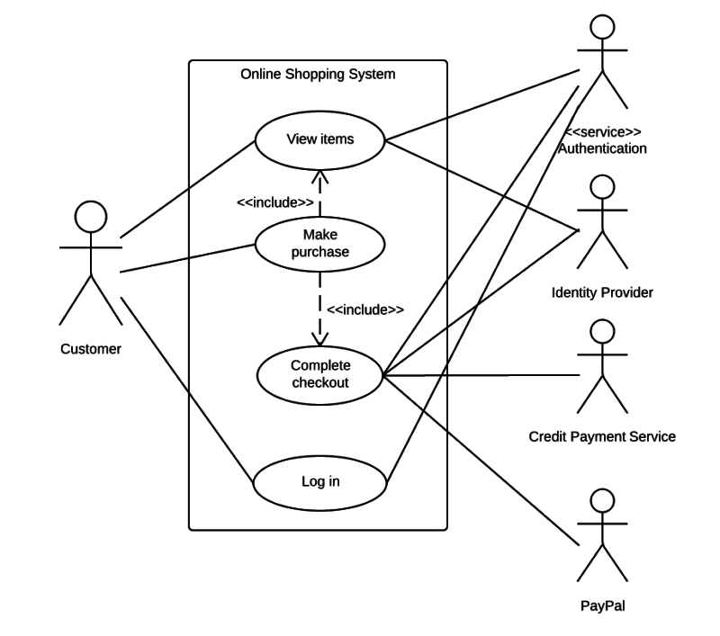

**3.3 Data Flow Diagrams:**

Data flow diagrams illustrate the flow of information within the Epic Dining Restro system. They map out how data moves from user inputs through various processes to the system's outputs, providing a clear understanding of the information exchange within the application.

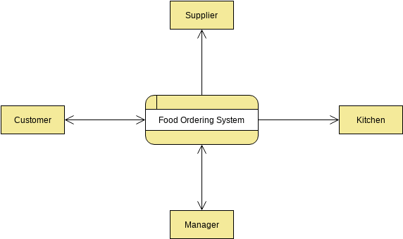

**3.4 Entity-Relationship Diagrams:**

Entity-Relationship Diagrams (ERD) highlight the relationships between different entities in the system, such as users, orders, menu items, and reservations. These diagrams serve as a blueprint for database design and management.

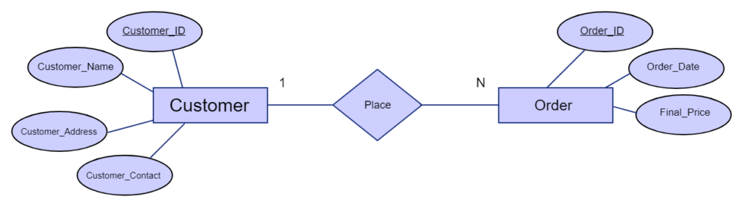

**3.5 System Architecture:**

This section outlines the overarching architecture of the Epic Dining Restro system. It illustrates the interconnections between the front-end, back-end, and database components, providing a comprehensive view of how the system is structured to deliver a seamless dining experience.

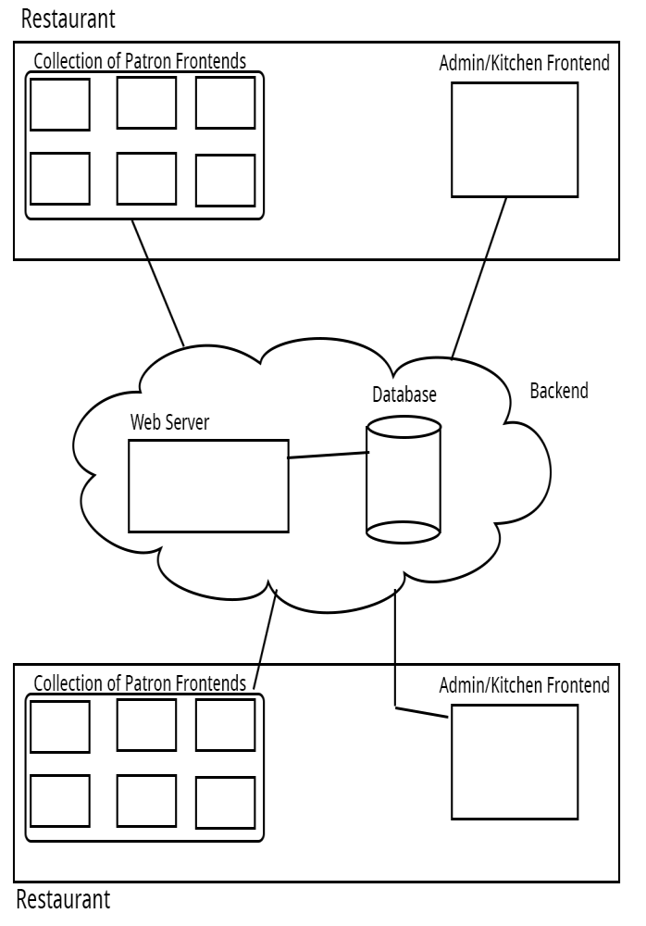

CHAPTER 4

Technological

**4.1 Front-End:**

**4.1.1 HTML**

* Semantic Structure: Utilize semantic tags to structure the web content logically (e.g., <header>, <nav>, <section>, <article>, <footer>).
* Menu Structure: Design a clear and intuitive menu structure using <nav> elements for easy navigation.
* Forms for Interactivity: Implement HTML forms for user interaction, such as reservation forms or feedback forms.

**4.1.2 CSS**

* Responsive Design: Use CSS media queries to ensure a responsive design that adapts to different screen sizes and devices.
* Branding and Theming: Apply consistent branding through styles, and use CSS variables for easy theming adjustments.
* Animations and Transitions: Enhance user experience with subtle animations and transitions for interactive elements.

**4.1.3 JavaScript**

* Dynamic Content: Use JavaScript to dynamically update content, such as real-time menu changes or promotions.
* Form Validation: Implement client-side form validation to enhance user input accuracy.

**4.2 Back-end Technologies:**

**4.2.1 PHP**

* Server-side Logic: Implement server-side logic for handling reservations, user authentication, and processing user requests.
* Template Integration: Integrate PHP with HTML to dynamically generate content based on server-side data.
* Security Measures: Apply PHP security best practices to protect against common vulnerabilities.

**4.2.2 MySQL**

* Database Schema: Design an efficient database schema for storing information such as menu items, user data, and reservations.
* Data Retrieval and Manipulation: Use MySQL queries to retrieve and manipulate data, ensuring fast and reliable performance.
* Normalization: Apply normalization techniques to organize data efficiently and reduce redundancy.

**4.3 Database Management System: XAMPP**

* Local Development Environment: Utilize XAMPP for a local development environment, including Apache for web server, MySQL for database management, and PHP for server-side scripting.
* Testing and Debugging: Leverage XAMPP's tools for testing and debugging before deploying changes to the live server.

CHAPTER 5

System Implementation

**5.1 Front-end Development:**

**5.1.1 Overview:**

* Briefly introduce the front-end development aspect of the Epic Dining Restro project.

**5.1.2 Objectives:**

* Clearly define the goals and objectives of the front-end development phase.

**5.1.3 Technologies Used:**

* List and describe the front-end technologies employed, such as HTML, CSS, JavaScript, and React.

**5.1.4 User Interface (UI) Design:**

* Provide insights into the UI design, including wireframes, mockups, and design principles.

**5.1.5 Responsiveness:**

* Explain how the front-end is optimized for various devices and screen sizes.

**5.1.6 User Experience (UX):**

* Discuss the strategies employed to enhance user experience on the Epic Dining Restro platform.

**5.1.7 Testing:**

* Describe the testing methodologies and tools used to ensure a robust front-end.

**5.2. Back-end Development:**

**5.2.1 Overview:**

* Provide an introduction to the back-end development phase.

**5.2.2 Objectives:**

* Clearly outline the goals and objectives of the back-end development.

**5.2.3 Technologies Used:**

* Enumerate and describe the back-end technologies implemented, such as php , MySQL .

**5.2.4 Server Logic:**

* Detail the server-side logic, including authentication, authorization, and data processing.

**5.2.5 Security Measures:**

* Discuss the security measures in place to protect user data and system integrity.

**5.2.6 Scalability:**

* The back-end architecture is designed to handle scalability requirements.

**5.3. Database Implementation:**

**5.3.1 Overview:**

* Introduce the database implementation phase and its significance.

**5.3.2 Database Design:**

* Detail the database schema, relationships, and rationale behind the chosen design.

**5.3.3 Database Management System (DBMS):**

* Specify the DBMS used (e.g., MySQL, Xampp) and justify the selection.

**5.3.4 Data Storage and Retrieval:**

* Data is stored, retrieved, and updated within the Epic Dining Restro database.

**5.3.5 Performance Optimization:**

* Discuss strategies employed to optimize database performance and ensure efficient queries.

**5.3.6 Backup and Recovery:**

* Outline the backup and recovery procedures in place to safeguard against data loss.

CHAPTER 6

Deployment and Maintenance

**6.1 Deployment Strategies:**

**6.1.1 Rollout Plan:**

* Develop a phased rollout plan for a smooth transition from development to production.
* Gradually introduce features to avoid overwhelming users and identify potential issues early.

**6.1.2 Environment Configuration:**

* Implement a consistent environment configuration for a reliable deployment process.
* Utilize containerization technologies like Docker for efficient deployment across different environments.

**6.1.3 Scalability Considerations:**

* Design the deployment architecture to be scalable for handling increasing loads seamlessly.
* Implement load balancing and caching mechanisms to optimize performance.

**6.2 Post-Deployment Support:**

**6.2.1 Monitoring and Analytics:**

* Set up comprehensive monitoring tools to track system performance and identify potential issues.
* Implement analytics for insights into user behavior and preferences for ongoing improvements.

**6.2.2 User Training and Documentation:**

* Provide training sessions for end-users to familiarize them with new features or changes.
* Maintain up-to-date documentation to assist users and support teams in troubleshooting.

**6.2.3 User Feedback Mechanism:**

* Establish a feedback mechanism to gather input from users post-deployment.
* Use feedback to address user concerns, identify areas of improvement, and enhance the overall user experience.

**6.3 Continuous Improvement and Updates:**

**6.3.1 Iterative Development Cycle:**

* Adopt an iterative development approach, releasing regular updates to address bugs and introduce new features.
* Use agile methodologies to prioritize and implement changes based on user feedback and business requirements.

**6.3.2 Security Patching:**

* Implement a robust system for monitoring and applying security patches promptly.
* Conduct regular security audits to identify and address potential vulnerabilities.

**6.3.3 Performance Optimization:**

* Continuously optimize system performance based on monitoring data and user feedback.
* Explore opportunities for code refactoring and improvements to enhance overall efficiency.

**6.3.4 Version Control and Rollback Procedures:**

* Utilize version control systems to manage code changes and releases effectively.
* Establish rollback procedures to quickly revert to a stable version in case of unforeseen issues.

CHAPTER 7

Conclusion

**7.1 Summary of Achievements:**

* **Successful Conceptualization:** The project effectively brought to life the concept of an epic dining experience, combining unique culinary offerings with a captivating ambiance.
* **High Customer Satisfaction:** Positive feedback and high customer ratings reflect the achievement of providing a memorable dining experience.
* **Financial Success:** The restaurant has not only met but exceeded revenue projections, demonstrating the viability of the business model.

**7.2 Lessons Learned:**

* **Customer Preferences:** Insights gained into customer preferences for cuisine, ambiance, and service have been instrumental in refining the restaurant's offerings.
* **Operational Efficiency:** Identifying and addressing operational challenges has led to improved efficiency in service delivery and overall management.
* **Marketing Strategies:** Understanding the importance of effective marketing and branding in the competitive restaurant industry has been a key lesson.

**7.3 Recommendations for Future Work:**

* **Innovation in Menu**: Continuously explore and introduce innovative menu items to keep the dining experience fresh and exciting for repeat customers.
* **Technology Integration:** Explore opportunities to leverage technology for improved customer service, reservations, and marketing strategies.
* **Community Engagement:** Strengthen ties with the local community through events, collaborations, and promotions to build a loyal customer base.

CHAPTER 8

Screenshots and Mockups

### 8.1 Website Home Page

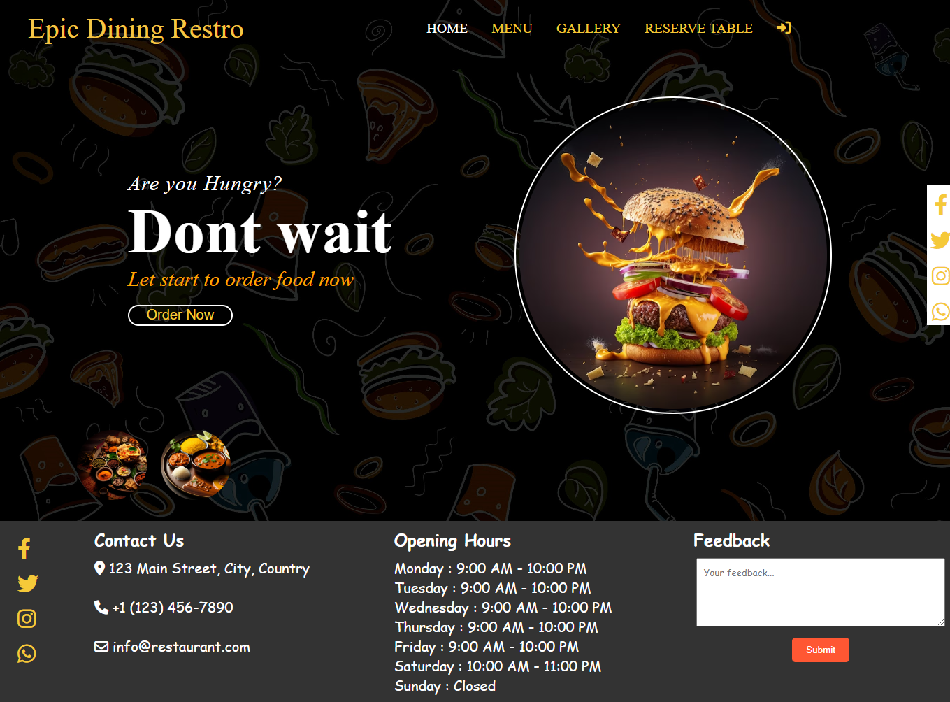

Figure 8.1 Website Home Page

### 8.2 User Registration Page

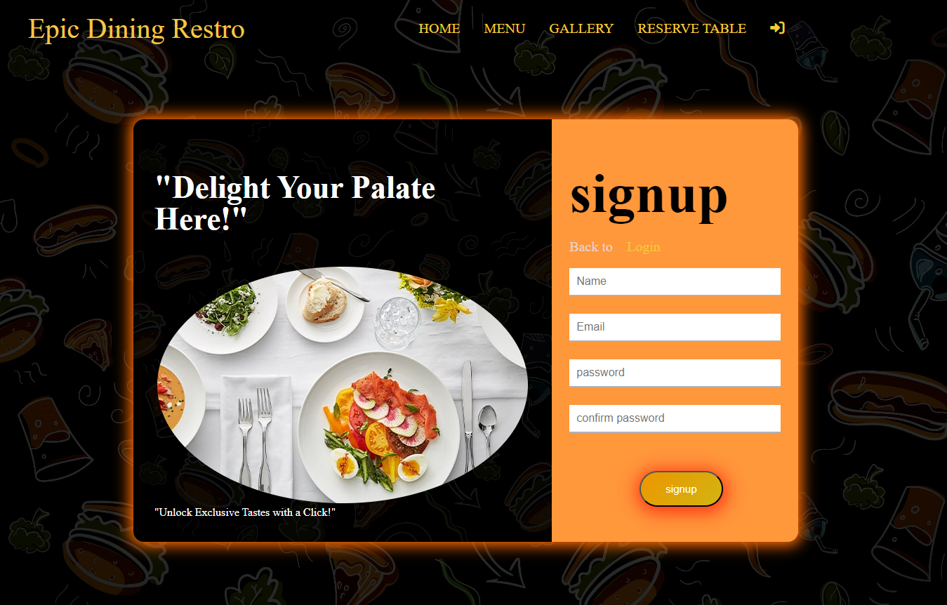

Figure 8.2 User Registration Page

### 8.3 User Login Page

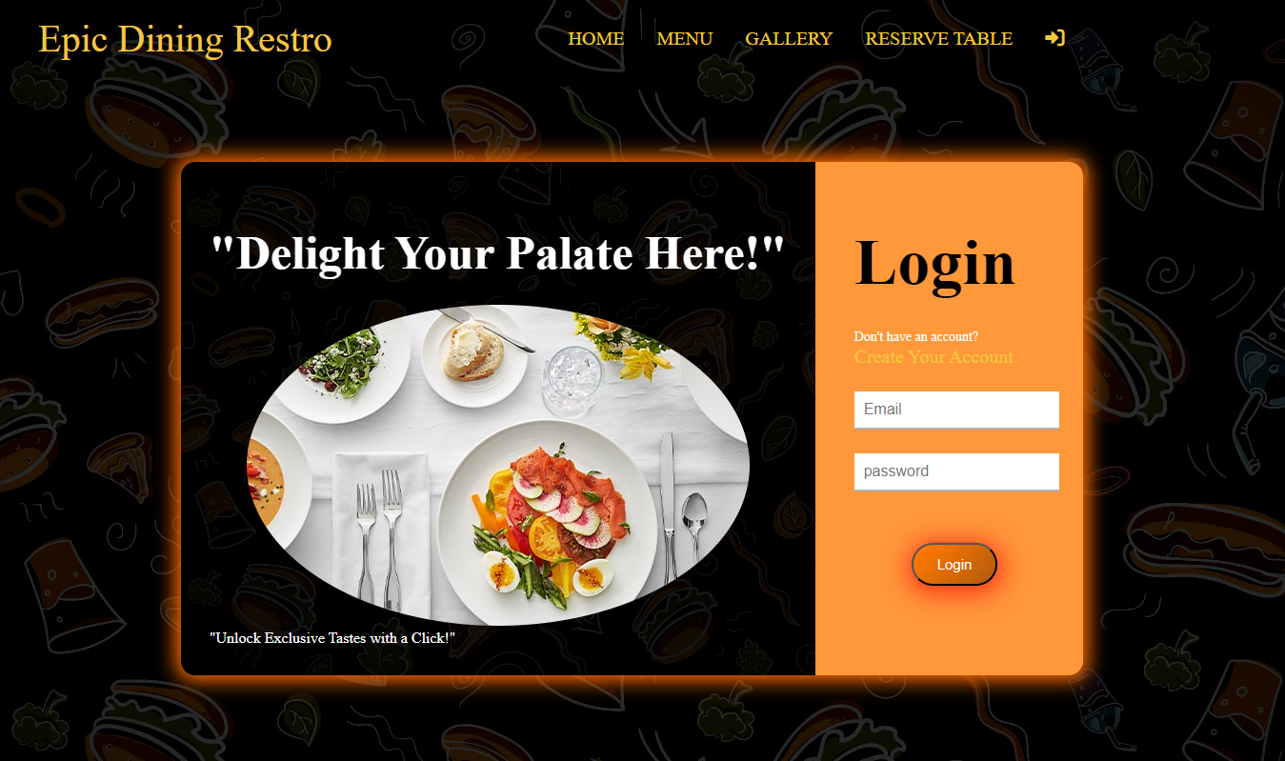

Figure 8.3 User Login Page

### 8.4 Resturant Menu Page

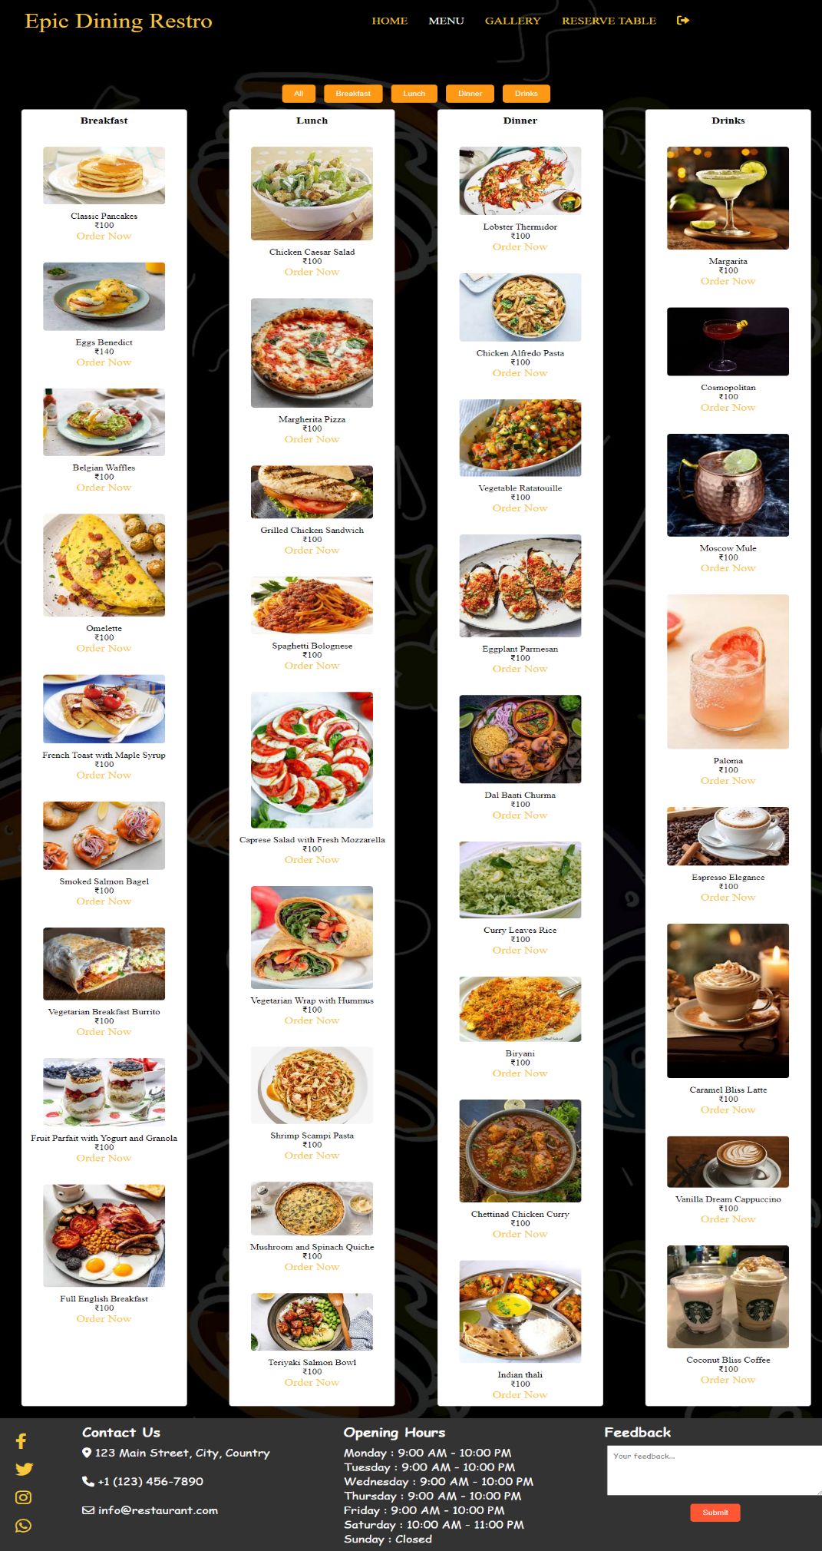

Figure 8.4 Resturant Menu Page

### 8.5 Resturant Gallery Page

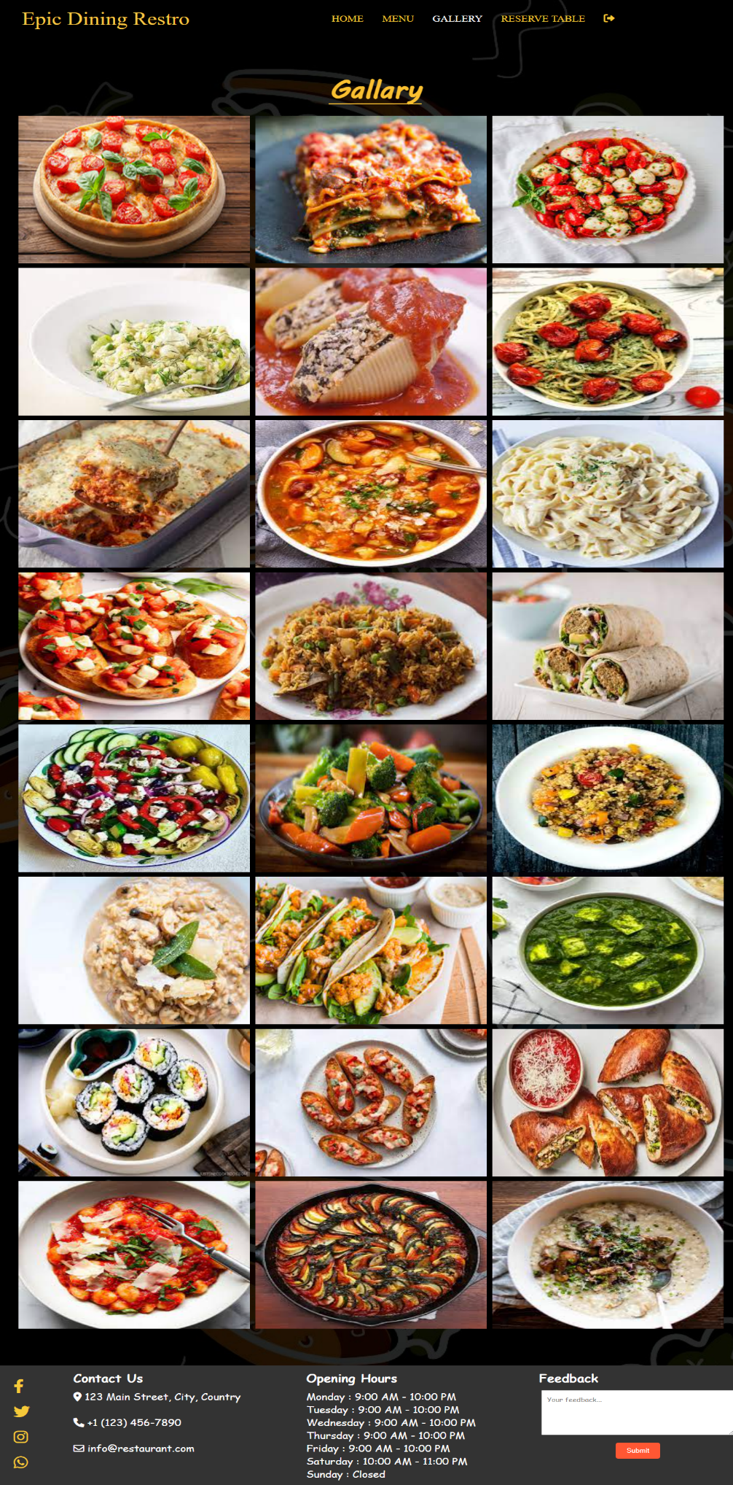

Figure 8.5 Resturant Gallery Page

### 8.6 Resturant Reserve Page

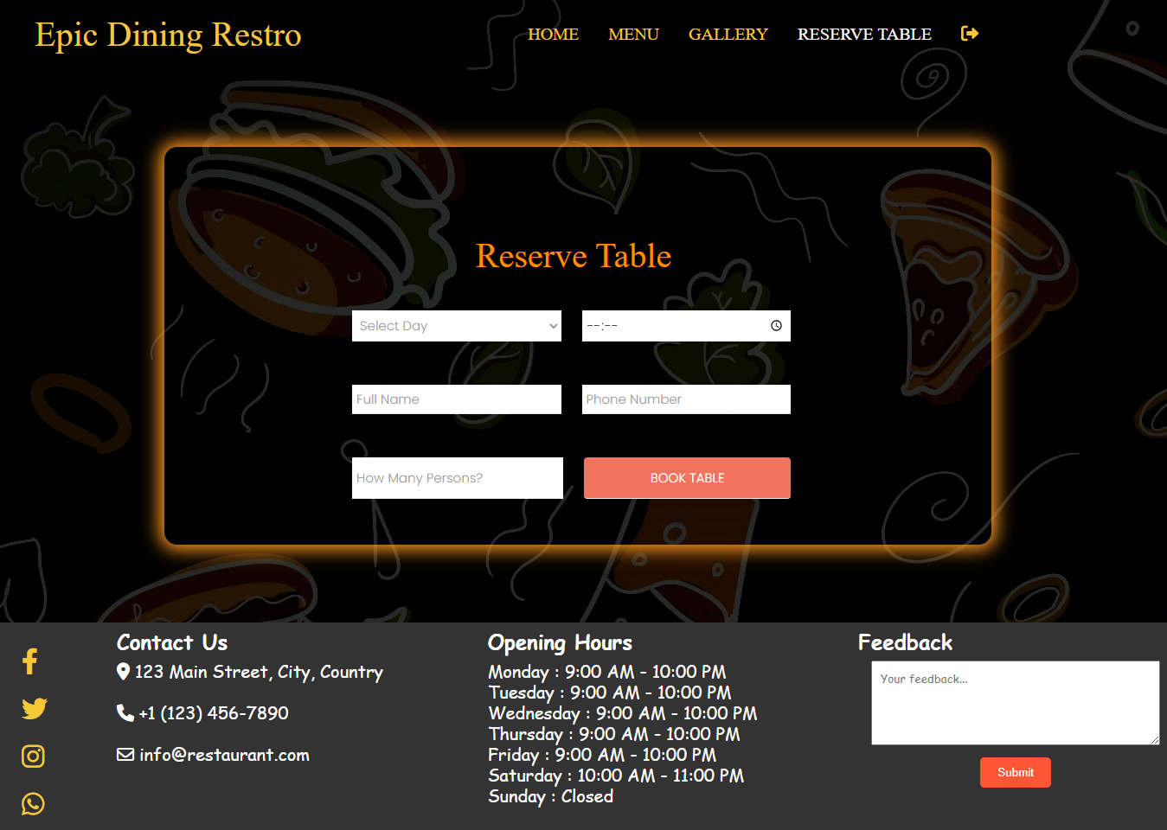

Figure 8.6 Resturant Reserve Page

### 8.7 Resturant Order Page

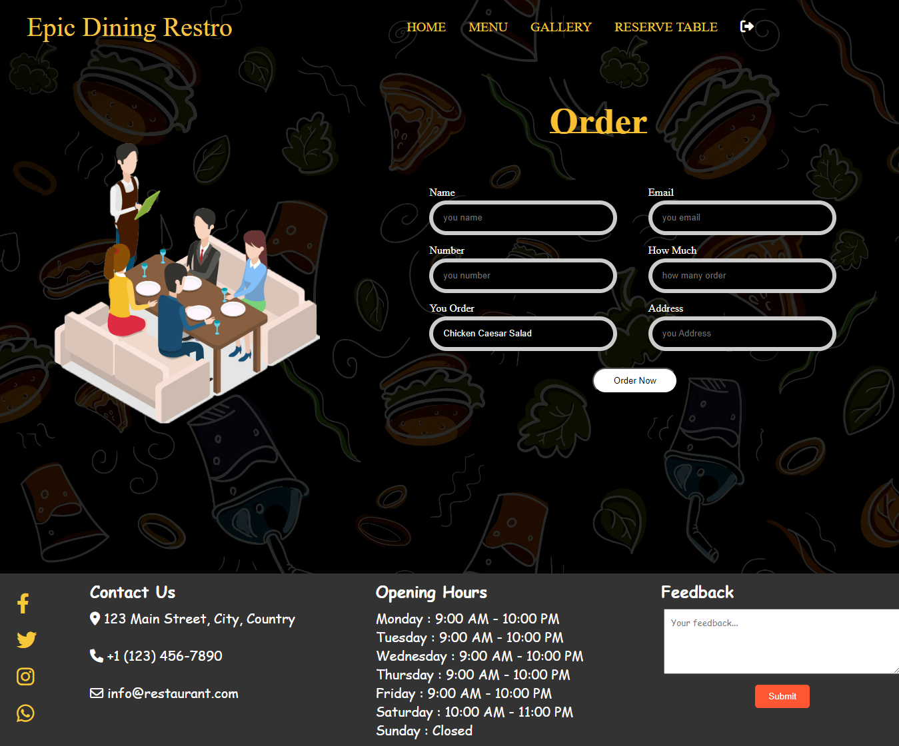

Figure 8.7 Resturant Order Page

CHAPTER 9

Screenshot of Database

**9.1 Signup Table**

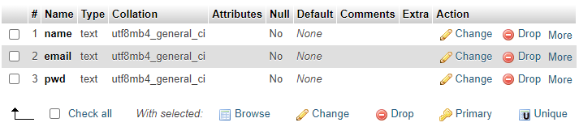

Figure 9.1 Signup Table

**9.2 Reserve Table**

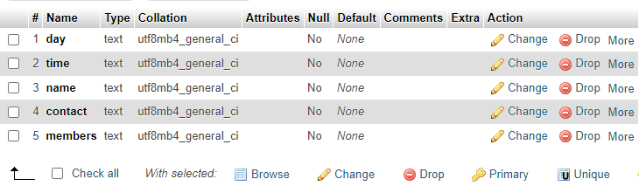

Figure 9.2 Reserve Table

**9.3 Order Table**

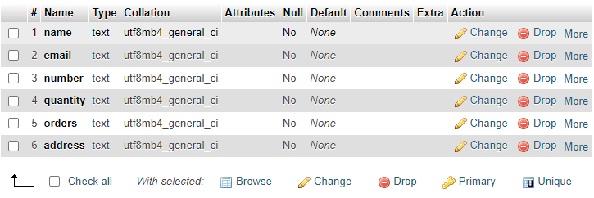

Figure 9.3 Order Table

**9.4 Feedback Table**



Figure 9.4 Feedback Table